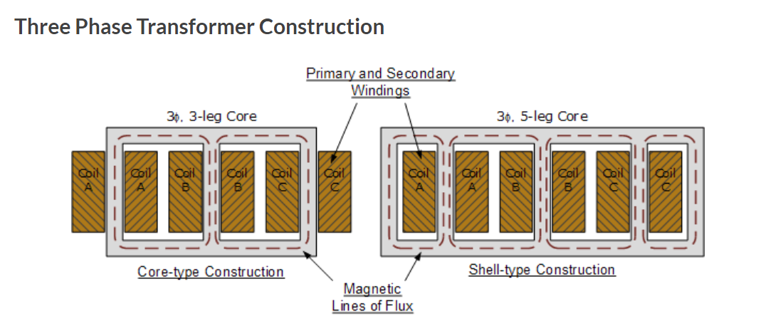Unveiling the "Secret Weapon" of Three-Phase Pad-Mounted Transformers: A Core Limbs Showdown
When it comes to the unsung heroes of power transmission, three-phase pad-mounted transformers are at the top of the list. These devices are the backbone of modern electrical infrastructure, ensuring reliable energy distribution to homes, businesses, and industries. At the heart of these transformers lies their core limbs, which are crucial components for determining performance and efficiency. Today, we’ll explore the intriguing differences between two configurations: the 3-phase 5-limb and the 3-phase 3-limb transformers.

The Marvel of 3-Phase 5-Limb Transformers
Think of the 3-phase 5-limb transformer as a sturdy structure supported by five columns. In this design, three primary limbs handle the magnetic flux for each phase, while two additional auxiliary limbs play a vital role in balancing and minimizing stray magnetic fields.
This design is particularly effective at reducing unbalanced currents during short circuits, which significantly enhances the transformer's stability and reliability. The auxiliary limbs provide additional paths for the magnetic flux, allowing for better control of the magnetic field and reducing the potential for energy losses.
Why Choose 3-Phase 5-Limb?
- Superior Control of Stray Magnetic Fields: The two extra auxiliary limbs allow for more precise management of stray magnetic fields, which helps in reducing energy losses and improving the transformer's efficiency.
- Enhanced Stability and Balance: The 5-limb configuration offers exceptional stability across various load conditions, making it a reliable choice for demanding applications .
- Reduced Vibration and Noise: By stabilizing the magnetic field, the auxiliary limbs help to minimize vibrations and operational noise, resulting in quieter and smoother performance.
Ideal Applications:
The 3-phase 5-limb transformers are often deployed in environments that demand high power quality, such as large commercial buildings, industrial parks, and data centers. Their superior balancing capabilities and enhanced stability make them ideal for these applications, where reliable power delivery is critical.

Exploring the Efficiency of 3-Phase 3-Limb Transformers
On the other hand, the 3-phase 3-limb transformer is a model of simplicity and efficiency. With only three limbs corresponding to the three phases, this design is more compact and streamlined, offering several advantages in specific scenarios.
Despite lacking auxiliary limbs, the 3-phase 3-limb transformer excels through optimized design and advanced materials, achieving impressive energy efficiency and reliability.

Why Opt for 3-Phase 3-Limb?
- Compact and Space-Efficient Design: The absence of auxiliary limbs results in a more compact transformer, making it ideal for installations where space is a premium.
- Efficient Energy Performance: Through optimized design, the 3-limb configuration achieves excellent energy efficiency, making it suitable for medium to small loads.
- Cost-Effective Solution: With a simpler design and fewer materials, the 3-phase 3-limb transformer offers a cost-effective solution without sacrificing essential performance.
Best Uses:
These transformers are well-suited for residential areas, small commercial facilities, and rural power grids. They provide an efficient power supply in situations where excessive redundancy isn't necessary, offering an optimal balance between cost and performance.

Making the Right Choice
Choosing between the 3-phase 5-limb and 3-phase 3-limb transformers depends on your specific needs and constraints. The 5-limb configuration provides enhanced stability and power quality for demanding applications, while the 3-limb configuration offers a compact, efficient, and cost-effective solution for smaller loads and limited space.
At JZP, we are dedicated to providing the best transformer solutions tailored to your needs. Whether you're looking for the power of the 5-limb or the efficiency of the 3-limb, we have you covered. Let's explore the mysteries of electricity together and unlock the full potential of these core limb designs!

**揭秘三相箱式变压器的“秘密武器”：铁心柱大比拼**
在电力传输的无名英雄中，三相箱式变压器无疑位居榜首。这些设备是现代电力基础设施的支柱，确保为家庭、企业和工业提供可靠的能源分配。而变压器的核心部件——铁心柱，则是决定其性能和效率的关键。今天，我们将探讨两种配置之间的有趣差异：三相五柱式变压器和三相三柱式变压器。

**三相五柱式变压器的卓越之处**
可以将三相五柱式变压器想象为由五根柱子支撑的坚固结构。在这种设计中，三根主柱分别处理每相的磁通，而两根额外的辅助柱则在平衡和减少杂散磁场方面发挥着至关重要的作用。
这种设计在短路时能有效减少不平衡电流，从而显著提高变压器的稳定性和可靠性。辅助柱为磁通提供了额外的路径，从而更好地控制磁场，并减少能量损耗的可能性。

**为什么选择三相五柱式？**
1. **卓越的杂散磁场控制**：两根额外的辅助柱可以更精确地管理杂散磁场，从而减少能量损耗并提高变压器的效率。
2. **增强的稳定性和平衡性**：五柱式配置在各种负载条件下都表现出卓越的稳定性，是要求严苛应用的可靠选择。
3. **减少振动和噪音**：通过稳定磁场，辅助柱有助于减少振动和运行噪音，从而实现更安静、更平稳的性能。

**理想应用场景**：
三相五柱式变压器通常部署在对电能质量要求较高的环境中，例如大型商业建筑、工业园区和数据中心。其卓越的平衡能力和增强的稳定性使其成为这些应用的理想选择，因为在这些场景中，可靠的电力供应至关重要。

**探索三相三柱式变压器的高效性**
另一方面，三相三柱式变压器则是简洁与高效的典范。仅由三根柱对应三相的设计使其更加紧凑和精简，在特定场景中具有多项优势。
尽管没有辅助柱，三相三柱式变压器通过优化设计和先进材料，依然实现了令人印象深刻的能效和可靠性。

**为什么选择三相三柱式？**
1. **紧凑且节省空间的设计**：由于没有辅助柱，变压器更加紧凑，非常适合空间有限的安装环境。
2. **高效的能源性能**：通过优化设计，三柱式配置实现了出色的能效，适合中小型负载。
3. **经济高效的解决方案**：凭借更简单的设计和更少的材料，三相三柱式变压器在不牺牲基本性能的前提下提供了经济高效的解决方案。

**最佳用途**：
这些变压器非常适合住宅区、小型商业设施和农村电网。在不需要过多冗余的情况下，它们提供了高效的电力供应，实现了成本与性能之间的最佳平衡。

**如何做出正确选择**
在三相五柱式和三相三柱式变压器之间做出选择，取决于您的具体需求和限制条件。五柱式配置为要求严苛的应用提供了增强的稳定性和电能质量，而三柱式配置则为较小负载和有限空间提供了紧凑、高效且经济实惠的解决方案。

在JZP，我们致力于为您提供量身定制的最佳变压器解决方案。无论您需要五柱式的强大性能，还是三柱式的高效表现，我们都能满足您的需求。让我们一起探索电力的奥秘，释放这些铁心柱设计的全部潜力！

